Hong Kong Birds Zone

1. Header menu, sample as follows:

<https://www.greening.gov.hk/en/home/>

1. Who we are

About Us

The Hong Kong Birds Zone was started in January 2010 with the aim to document all the wild birds in Hong Kong through individual species accounts. As it was a resource aimed at current birders and photographers of all level, we included information we thought to be useful, including photos of the birds, written description on their appearance, their preferred habitat, behaviour, other key features, as well as links to outside resources. The foundation for the website and its content was a constantly updated and accurate bird checklist kept in a database that gradually expanded to include all the elements necessary to support individual species write-ups.

In 2021, we formed the Hong Kong Bird Records Committee (RC) to better assess the status of Hong Kong’s avifauna through a formal foothold. We conceptualised and built an integrated RC voting system from the ground up, and an online user record submission system to go with it. In parallel, we published an online resource known as Hong Kong Bird Database. In it, all known sightings of key species in Hong Kong are easily searchable, with highly detailed information, links to primary resources, and our RC’s assessment on the individual records.

Starting with a small team, we gradually expanded through the years and slowly completed our species accounts. Tying together all these complex elements into a coherent whole took some time but we are now largely done, and can now focus our energy on some newer projects. Feedback, recommendations and ideas for collaboration are warmly welcome. We believe that the community plays a strong role in documenting our avifauna collectively, and we in-turn work with fervour to create content we are confident will serve the local and regional birding community.

Our mission

We support a diverse, Hong Kong community of bird lovers who use the power of science, . exploration, education, and storytelling to illuminate and protect the wonder of our world.

Contributors

Writing Team:

Brian Chan

Francis Yip

Dyson Sin

Richard Woo

Sandra Ng

Note: The Writing Team makes no representation regarding the completeness, accuracy, or timeliness of any information and data posted on the Site or that such information and data will be error-free.

Photo Credits:

Albert Lo

Alen Yu

Alvis Ma

Calvin Cheung

Chong Bo Leung

Cheung Chi Yi

Chris Pow

Daniel Wu

David Mao

Eric Tong

Fishy Fu

Francis Yiu

Jason Ng

Jerold Tan

Johnson Chan

Karson Fung

Kenneth Chow

Leslie Wong

Roy Shing

Shirley Shum

Tan Chi Ho

Vincent Lung

Database Design: Keith Kwok

Cover Design: Davina Ng

Site admin and coding: Kelvin Yip

1. Hong Kong Bird Database

Record

What is the important information displayed?

* Species
* Date first seen
* Location
* Any media (images or audio files) If unavailable, descriptions entered by the observer are displayed instead
* References
* Last date of record updated

Species or Record ID

Search

Only show accepted records

Search by data instead



This database provides up-to-date information regarding focal bird species in Hong Kong, which also includes species that are not on our checklist. Records of bird species are accompanied by easily accessible links to primary documents. More details on the methodology and background behind this database are available in this blog post.

See the Review List for more details on the species that we have compiled records for, as well as the number of records for each species.

The references used to compile this database are listed in the references page.

Entering a species name or unique record ID above will show a list of all. records. associated with the search term. Click on any unique record ID to explore specific details of a record.

Record submission

Personal information

Your name*

Your email address*

Other observers (Optional)

Sighting details

Species*

Date first seen*

Time of observation

Location*

Supporting information

Describe what you saw/recorded, as well as your identification criteria

Discuss the behavior of the bird(s) and the habitat it was seen in

Describe the viewing conditions

I acknowledge I am the the sole owner of the photos/audio uploaded. I give my consent to the Hong Kong Birds Zone to use and display my photos/audio with appropriate credits (optional).

Upload photos below (maximum of ? files, up to 5 MB each)

Example: [Record 10326: Common Moorhen (singaporebirds.com)](https://records.singaporebirds.com/record/10326/)

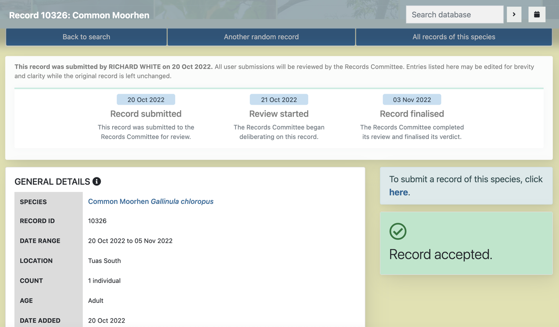

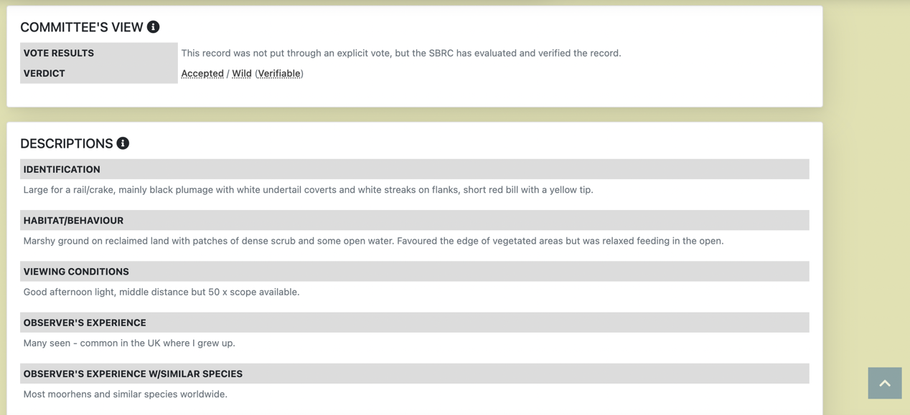

1. Hong Kong Bird list

**Chestnut Bulbul 栗背短腳鵯**

Tai Po Kau  
9/9/2022  
  
Very hot and quiet. Saw less than ten birds in a brief walk to Tai Po Kau on 9/9/2022

**Orange-bellied Leafbird**

7/2/2022  
TPK

**Scarlet Minivet**

20/1/2022 TPK

**Red-whiskered Bulbul - Lamma**

Red-whiskered Bulbul...Tai Shan West, Lamma Island, Hong Kong  
Monday 20th November 2017  
D500 300 AFS 1:4D  
(full frame)

**Blue-winged Leafbird 藍翅葉鵯**

6.2.2017  
Tai Po Kau

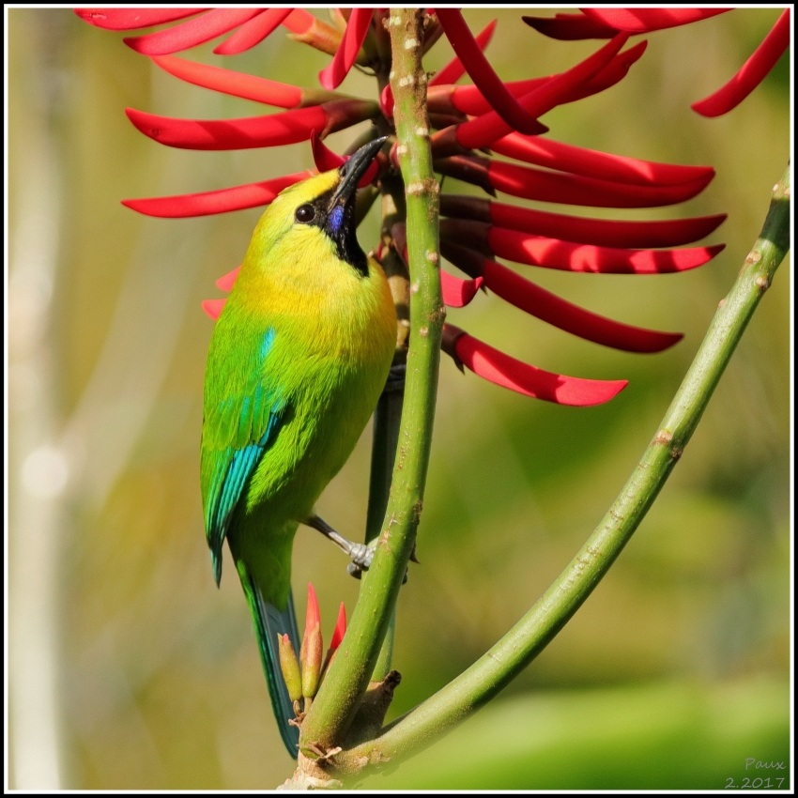

1. Hong Kong Bird Report

**Black-faced Spoonbill population hits record high of 6,000  
Slight rebound in Deep Bay reflects population levelling off**

Post at 1/04/2022

Coordinated by The Hong Kong Bird Watching Society (HKBWS), The International Black-faced Spoonbill Census 2022 was conducted from 7th to 9th January. **Global population of Black-faced Spoonbills (BFSs) reaches another record high of 6,162**, a rise of 18% (i.e. 940 individuals) from last year. **369 individuals were recorded in Deep Bay, including Hong Kong and Shenzhen side.** While the figure shows a rebound of 9.8%, **it has become stabilized** and does not differ fundamentally from those of previous years.  
  
**BFS global population breaks record for 9th time in decade**  
The 2022 census covered about 150 sites all over the world. All wintering sites, except for Macau and the Philippines, reported growing BFS populations. Taiwan remains the largest congregation site. Number of BFSs recorded there increases by 22.1% to reach 3,824, constituting 62% of the world population. Japan, too, is seeing a surge of 19.8% and recorded 683 individuals. With rebounding numbers in both Deep Bay and mainland China, promising signs from all major wintering sites help boost global BFS population to surpass 6,000 for the first time, making 2022 the 9th recording-breaking year over the past decade. Besides, we are delighted to have two individuals wintering in Malaysia, a new southern record since the census was first launched in 1994. New sightings suggest the BFSs may disperse over a large area in Southeast Asian region to roost.  
  
**Hong Kong population recovers, with declining share of global total**  
After two consecutive years in decline, Deep Bay BFS population gains 33 individuals this year and bounces back to 369. More BFSs were recorded in the Mai Po Nature Reserve and the Hong Kong Wetland Park, where habitat management measures are in place to provide suitable roosting sites for them. Mr. Yu Yat-tung, Director of HKBWS, noted that a mild growth was insufficient to determine whether habitats in Deep Bay have been restored. "Rising numbers in Hong Kong is largely attributed to surging global population, as more BFSs stopped over in Hong Kong and spent the winter here."  
  
Less than two decades ago, Hong Kong was the winter home to one-fifth of BFS population worldwide. However, ever since Deep Bay population reached an all-time high of 462 individuals in 2010, its growth has stalled and the number has been hovering around 300 since 2016. Meanwhile, global figure continues to pick up steadily. Populations in Taiwan, mainland China and Japan keep hitting new record highs. At present, BFSs in Deep Bay constitutes only 6% of the global total.  
  
**Prospects of Deep Bay conservation hinges on the Northern Metropolis**  
Keeping wetland ecosystem in Deep Way intact is a prerequisite for attracting more BFSs during fall migration. The three Wetland Conservation Parks proposed under the Northern Metropolis Development Strategy can bring opportunities for conservation. Yu stressed that the Parks have to be spacious, eco-friendly with minimal human disturbance. "The Parks cannot be small. They must be large enough to provide abundant food supply for the BFSs."  
  
Yu suggested that the "Inner Deep Bay and Shenzhen River catchment area", an Important Bird Area recognized by BirdLife International, be included in the Wetland Conservation Parks or designated as a restricted area under the Wild Animal Protection Ordinance. Long term conservation plans and habitat management measures are needed to preserve fishponds, mudflats and coastal wetlands in areas from Pak Nai to Ma Tso Lung. Feeding grounds for migratory birds including intertidal mudflats and fishponds should remain active both before and after government’s land resumption. Eco-friendly measures should remain in place, e.g. draining fishponds after harvest to let waterbirds feed on trash fish left on the muddy pond bottom. Finally, restricted areas should be delineated in the Wetland Conservation Parks to protect BFSs from human disturbance. For the sake of preserving Deep Bay's biodiversity, HKBWS again calls on government to make proper planning, set out a land resumption timetable for conservation and expand the nature reserve.

Footer:

© 2022 The Hong Kong Birds Zone. All rights reserved.

Last Revision Date: 11 Jan 2023

Important Notices

**Important Notices**

PLEASE READ THE FOLLOWING TERMS AND CONDITIONS CAREFULLY BEFORE USING THIS WEBSITE. BY USING THIS WEBSITE YOU AGREE TO ABIDE BY THE TERMS AND CONDITIONS SET OUT BELOW.

**Copyright Notices**

The content available on this website, including but not limited to all text, graphics, drawings, diagrams, photographs and compilation of data or other materials are subject to copyright owned by the Government of the Hong Kong Special Administrative Region or other entities. Except as expressly permitted herein or where prior written authorization is obtained from the Hong Kong Birds Zone - Works Branch, any reproduction, adaptation, distribution, dissemination or making available of such copyright works to the public is strictly prohibited.

Permission is granted for users to download the materials herein to store them in local computers, provided that this is solely for personal or non-commercial internal use, and provided further that this copyright notice is downloaded at the same time. Users should note that this permission only applies to copyright materials. Where third party copyrights are involved, an appropriate notice will appear in this website.

**Disclaimer**

The information contained in this website is compiled by the Hong Kong Birds Zone (“HKBZ”) for general information only. Whilst the HKBZ endeavours to ensure the accuracy of this general information, no statement, representation, warranty or guarantee, express or implied, is given as to its accuracy or appropriateness for use in any particular circumstances.

This website can also contain information contributed by others over whom, and in respect of which, the HKBZ may have no influence. Users may link from this website to sites provided by others. The Government expressly states that it has not approved or endorsed the information provided by others on this website or any other sites linked to this website and the HKBZ accepts no responsibility or liability (howsoever caused) for such information.

HKBZ is not responsible for any loss or damage whatsoever arising out of or in connection with any information including data or programmes on this website. HKBZ reserves the right to omit, suspend or edit all information compiled by HKBZ in this website at any time in its absolute discretion without giving any reason or prior notice. Users are responsible for making their own assessment of all information contained in this website and are advised to verify such information by making reference, for example, to original publications and obtaining independent advice before acting upon it.